1. 
2. **Agenda**:
   1. We will be testing a real world API.
3. 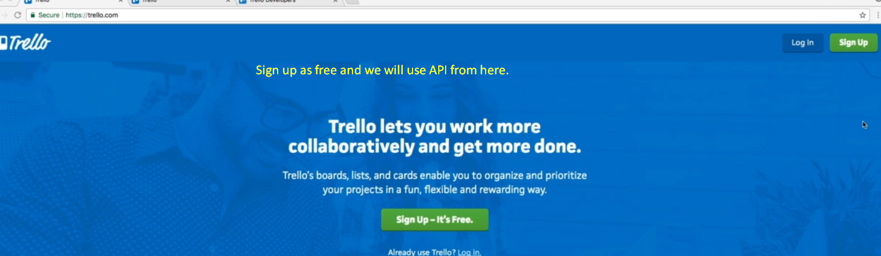
4. 
5. 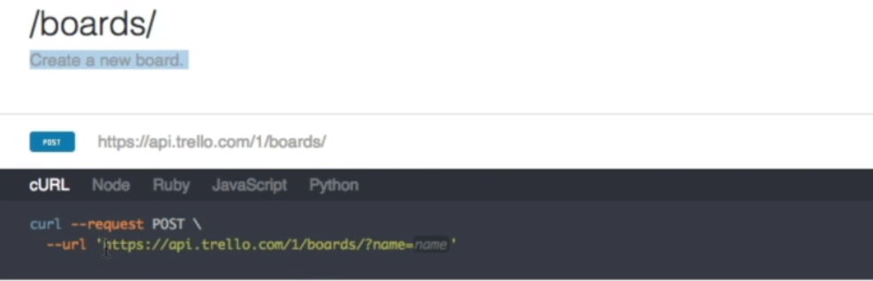
6. 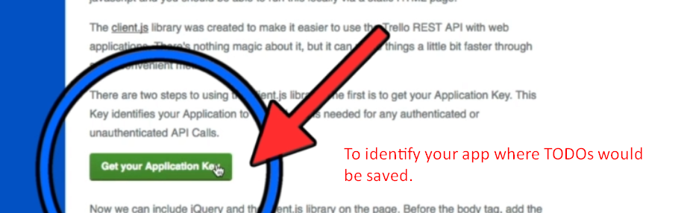
7. 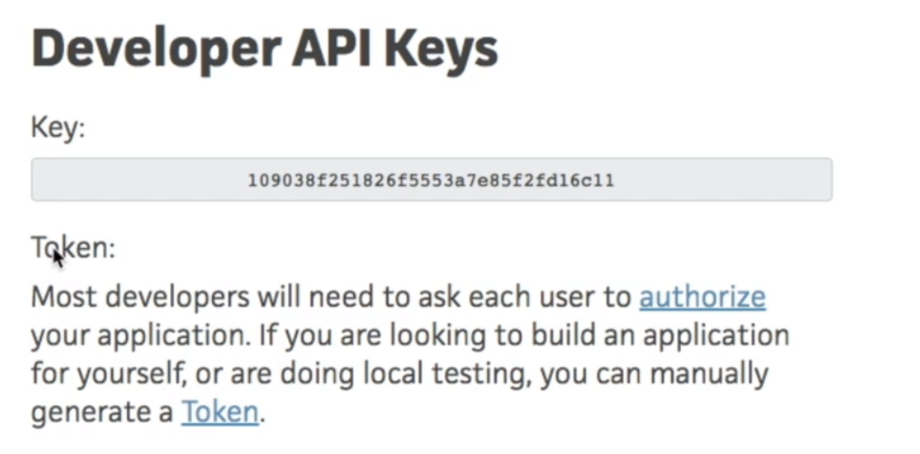
8. 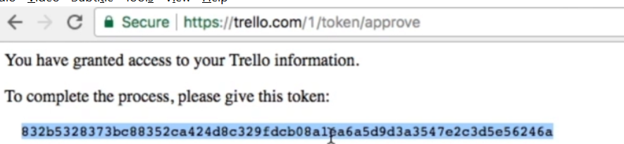
9. 